Frontiers of Condensed Matter and Quantum Physics
Schedule (July 4 – July 17, 2026)
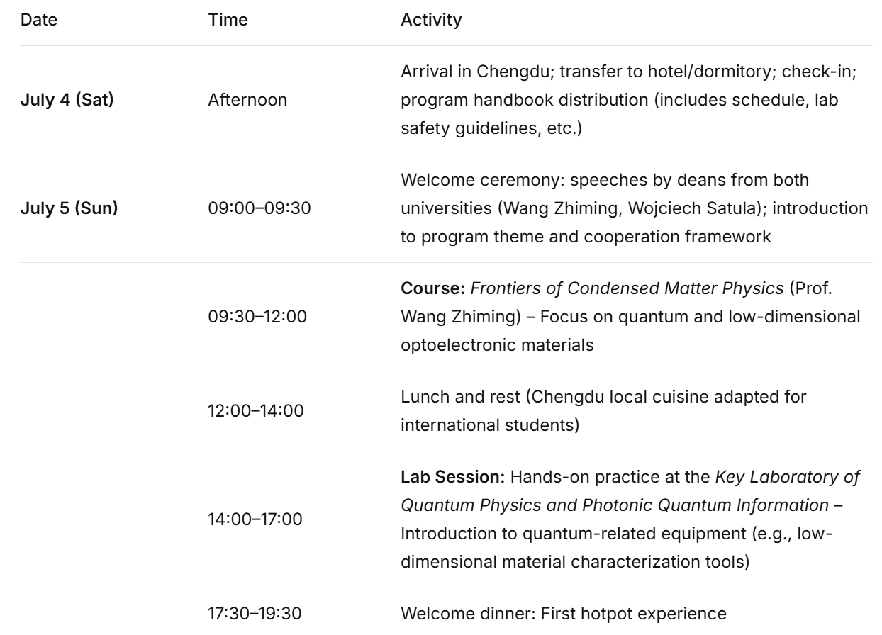
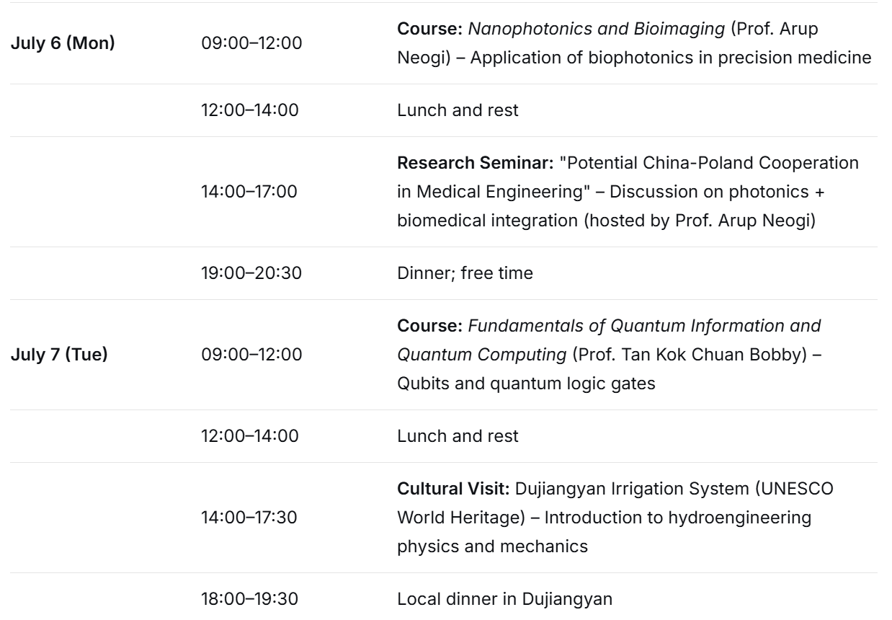
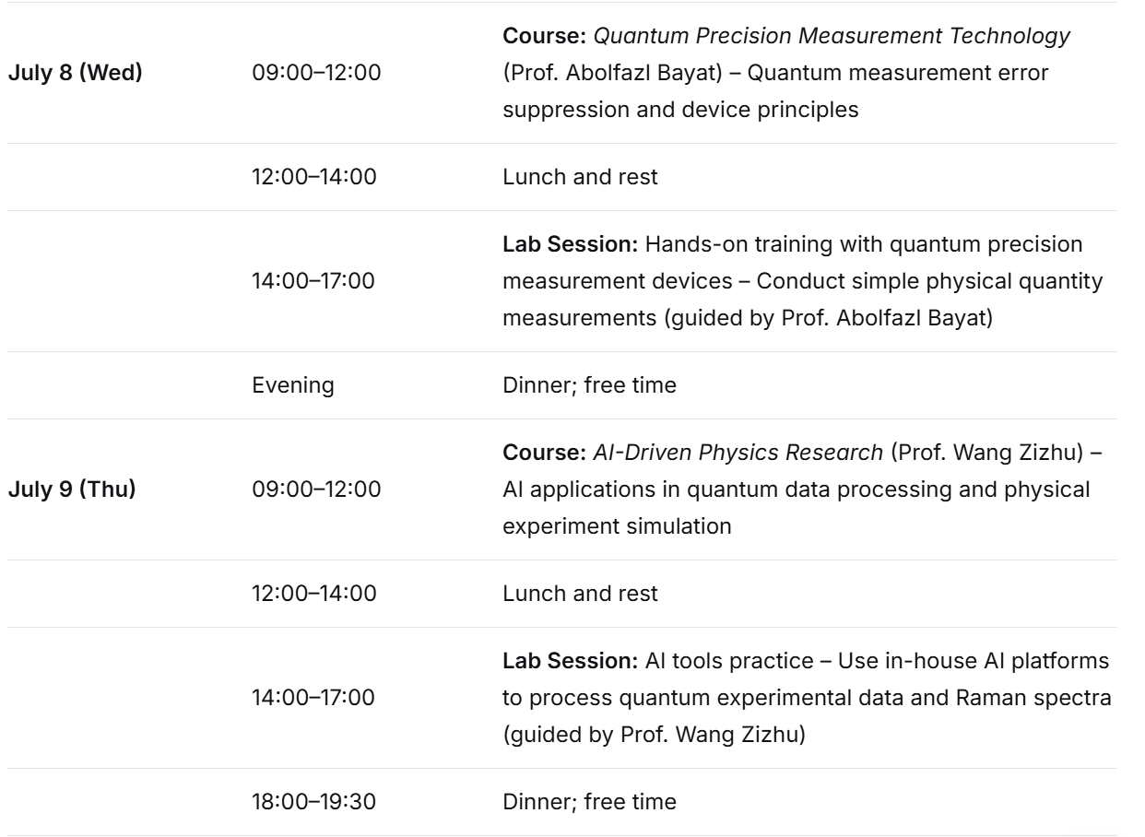
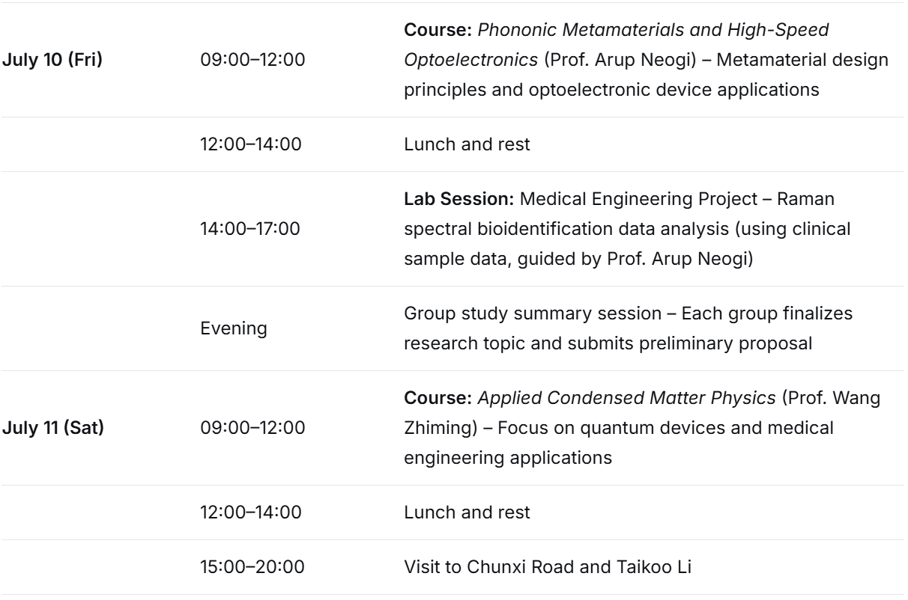
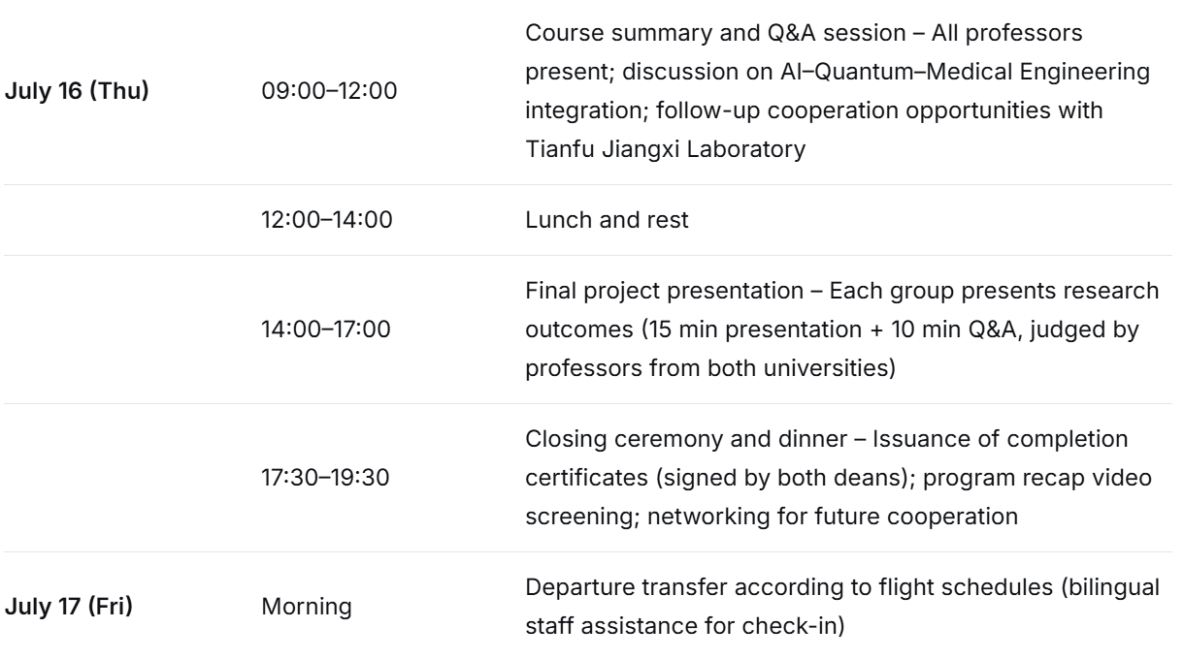
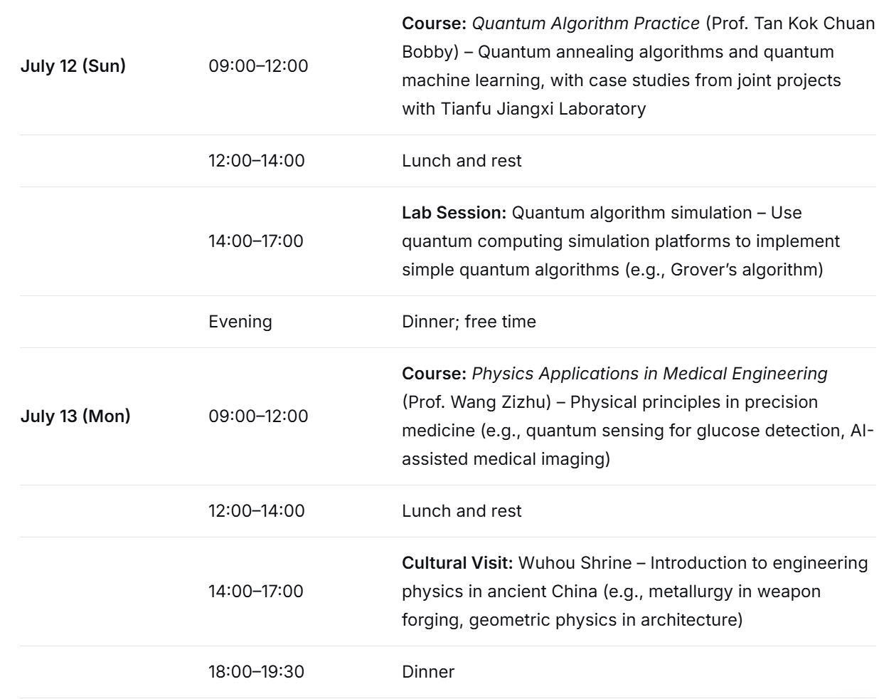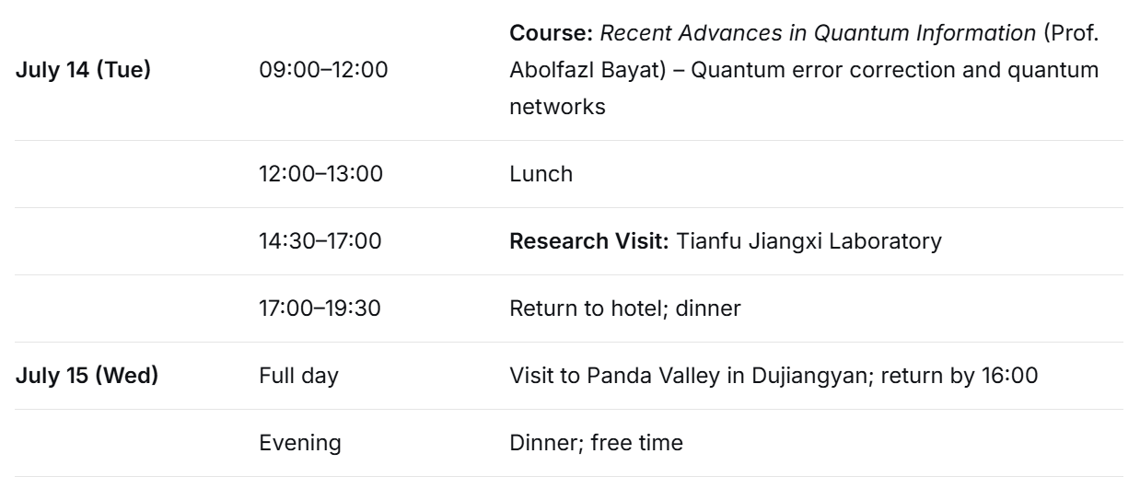

A Note on Our Program Schedule:
To help you visualize your two-week journey with us, we have prepared this detailed daily schedule. It aims to outline the exciting academic sessions, lab work, and cultural experiences we have in store.
Please view this schedule as a general guide rather than a fixed itinerary. Our priority is to deliver the best possible learning experience. Therefore, the exact timing or sequence of activities might be adapted to optimize learning outcomes, accommodate guest speaker schedules, or respond to students' interests and progress.
Rest assured, all key components and learning objectives of the program will be fulfilled. Any adjustments made will be clearly communicated to you in advance by our program coordinators.
We look forward to a dynamic and engaging summer school with you!

